Big O Time Efficiency* Examples

O(1) — constant
- finding a median value in a sorted array
- accessing any element in an array or ArrayList
- Push, Pop, Peek, and isEmpty operations for a stack (containing n elements);
- add, remove, peek, & isEmpty methods in PriorityQueue
- Insert and Remove operations for a queue.
- finding a key in a lookup table
- finding a key in an efficient, sparsely populated hash table
- retrieving a target value in an efficient, sparsely populated hash table
- adding an element to the end of an ArrayList
- addFirst, addLast, getFirst, getLast, removeFirst, & removeLast methods in LinkedList
- put, get, containsKey, & size methods in HashMap
- add, remove, contains, & size methods in HashSet

O(log n) — logarithmic
- Binary Search in a sorted list of n elements
- searching a balanced binary search tree (worst case is O(n) if BST is unbalanced)
- inserting a node into a binary search tree
- add and remove methods in PriorityQueue (implemented as a heap)

containsKey, get, & put methods in TreeMap
O(n) — linear
- traversing a List (e.g. finding max or min)
- sequential search through an array or ArrayList
- calculating the sum of n elements in an array, ArrayList, List, or Set
- calculating n-factorial with a loop
- calculating Fibonacci numbers with a loop
- traversing a tree with n nodes

O(n log n) — “n log n” time
- Mergesort
- Quicksort
- Heapsort
- creating a binary search tree if nodes inputted in random order leading to a balanced BST (worst case is O(n²))

O(n²) — quadratic
- Selection Sort
- Insertion Sort
- Bubble Sort
- traversing a two-dimensional array
- finding duplicates in an unsorted list of n elements (using nested loops)

O(n³) — cubic
- Conventional algorithm for matrix multiplication

O(a^{n}) (where a > 1) — exponential time
- Recursive Fibonacci implementation
- Towers of Hanoi
- Generating all permutations of n letters
- Set partitioning
- Traveling salesman problem – dynamic programming solution

O(n!) — factorial
- Traveling salesman problem – brute force solution
- Determinant Expansion by Minors
* most efficiencies are best case or average case unless noted

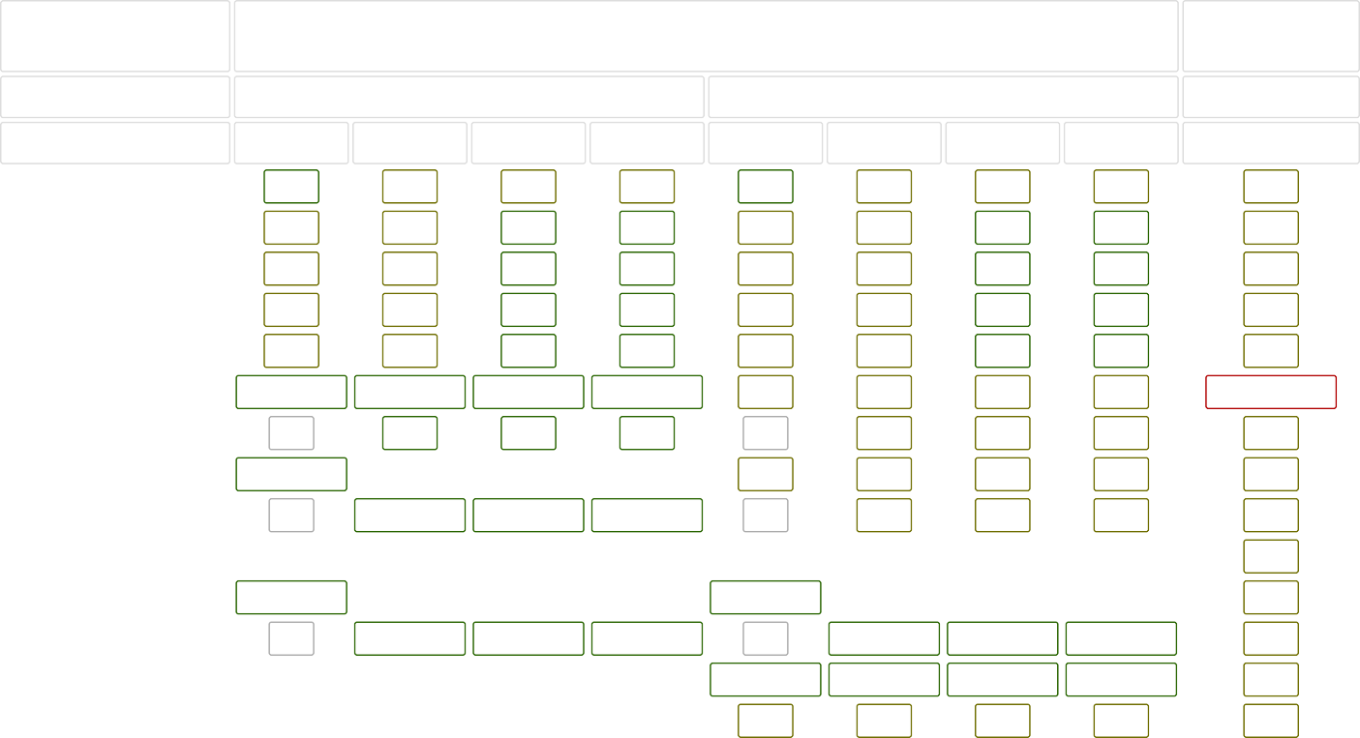
Common Data Structure Operations
Data Structure
Time Complexity

Average
Worst
Space Complexity
Worst

 | Access | Search | Insertion | Deletion | Access | Search | Insertion | Deletion
Array | Θ(1) | Θ(n) | Θ(n) | Θ(n) | O(1) | O(n) | O(n) | O(n) | O(n)
Stack | Θ(n) | Θ(n) | Θ(1) | Θ(1) | O(n) | O(n) | O(1) | O(1) | O(n)
Queue | Θ(n) | Θ(n) | Θ(1) | Θ(1) | O(n) | O(n) | O(1) | O(1) | O(n)
Singly-Linked List | Θ(n) | Θ(n) | Θ(1) | Θ(1) | O(n) | O(n) | O(1) | O(1) | O(n)
Doubly-Linked List | Θ(n) | Θ(n) | Θ(1) | Θ(1) | O(n) | O(n) | O(1) | O(1) | O(n)
Skip List | Θ(log(n)) | Θ(log(n)) | Θ(log(n)) | Θ(log(n)) | O(n) | O(n) | O(n) | O(n) | O(n log(n))
Hash Table | N/A | Θ(1) | Θ(1) | Θ(1) | N/A | O(n) | O(n) | O(n) | O(n)
Binary Search Tree | Θ(log(n)) | Θ(log(n)) | Θ(log(n)) | Θ(log(n)) | O(n) | O(n) | O(n) | O(n) | O(n)
Cartesian Tree | N/A | Θ(log(n)) | Θ(log(n)) | Θ(log(n)) | N/A | O(n) | O(n) | O(n) | O(n)
B-Tree | Θ(log(n)) | Θ(log(n)) | Θ(log(n)) | Θ(log(n)) | O(log(n)) | O(log(n)) | O(log(n)) | O(log(n)) | O(n)
Red-Black Tree | Θ(log(n)) | Θ(log(n)) | Θ(log(n)) | Θ(log(n)) | O(log(n)) | O(log(n)) | O(log(n)) | O(log(n)) | O(n)
Splay Tree | N/A | Θ(log(n)) | Θ(log(n)) | Θ(log(n)) | N/A | O(log(n)) | O(log(n)) | O(log(n)) | O(n)
AVL Tree | Θ(log(n)) | Θ(log(n)) | Θ(log(n)) | Θ(log(n)) | O(log(n)) | O(log(n)) | O(log(n)) | O(log(n)) | O(n)
KD Tree | Θ(log(n)) | Θ(log(n)) | Θ(log(n)) | Θ(log(n)) | O(n) | O(n) | O(n) | O(n) | O(n)

Array Sorting Algorithms
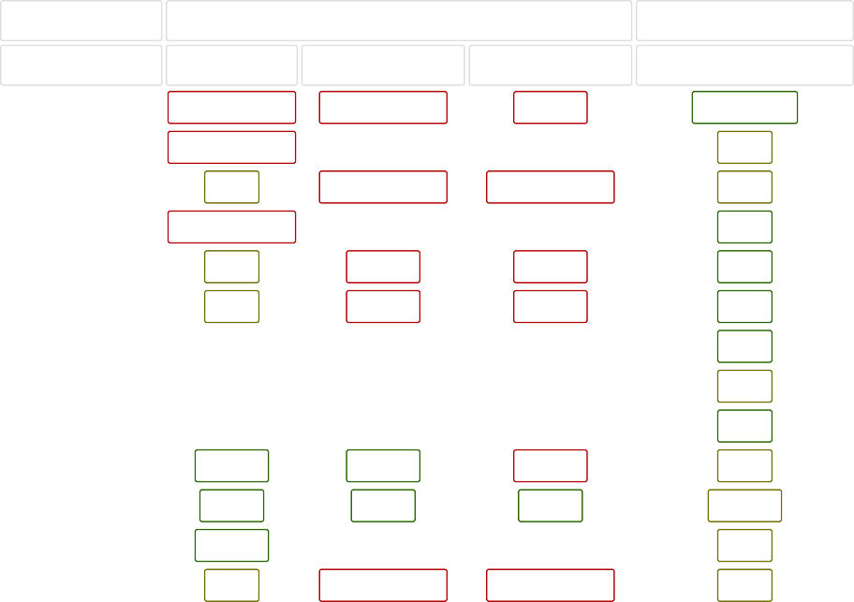
Algorithm
Time Complexity
Quicksort Mergesort Timsort Heapsort Bubble Sort Insertion Sort Selection Sort Tree Sort Shell Sort Bucket Sort Radix Sort Counting Sort
Cubesort
Best
Ω(n log(n))
Average Worst
Θ(n log(n)) O(n^2)
Space Complexity Worst
O(log(n))
Ω(n log(n))
Θ(n log(n))
O(n log(n))
O(n)
Ω(n)
Θ(n log(n))
O(n log(n))
O(n)
Ω(n log(n))
Θ(n log(n))
O(n log(n))
O(1)
Ω(n)
Θ(n^2)
O(n^2)
O(1)
Ω(n)
Θ(n^2)
O(n^2)
O(1)
Ω(n^2)
Θ(n^2)
O(n^2)
O(1)
Ω(n log(n))
Θ(n log(n))
O(n^2)
O(n)
Ω(n log(n))
Θ(n(log(n))^2)
O(n(log(n))^2)
O(1)
Ω(n+k)
Θ(n+k)
O(n^2)
O(n)
Ω(nk)
Θ(nk)
O(nk)
O(n+k)
Ω(n+k)
Θ(n+k)
O(n+k)
O(k)
Ω(n)
Θ(n log(n))
O(n log(n))
O(n)

